SECTION A
TRUE & FALSE QUESTIONS (10 MARKS)
(INSTRUCTION: Write your answer either TRUE (T) or FALSE (F) based on the following statements.)

- Error detection and response include only internal hardware error under services provided by operating system.  - Sharing system resources require the operating system to ensure that an incorrect program cannot have other programs to do incorrectly.  - During program execution, only instructions must be loaded into main memory.  - The Processor Manager of a modern operating system performs its tasks in isolation with other managers.  - General-purpose operating system does not fulfill the requirement of hard real-time systems.  - The File Manager is responsible for the creation of a process.  - The overhead for context switching varies from machine to machine, depending on the processor size.  - fork() system call is use to create a process under supervisor mode of the computer system.  - A truth table diagram can tell what event causes a process to change states.  - Operating system provides mechanism for process creation and process termination. | [ F ]  [ T ]  [ ]  [ ]  [ ]  [ ]  [ ]  [ ]  [ ]  [ ]
SECTION B
STRUCTURED QUESTIONS (50 MARKS)
(INSTRUCTION: Please answer all questions in the space provided)

QUESTION 1 [12 Marks]

a) Based on Figure 1, complete the diagram. [2 marks]
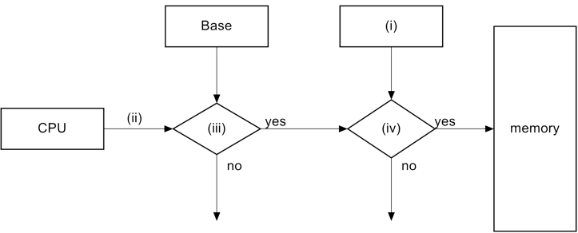

Figure 1: Memory Protection
Answer:
- BASE + LIMIT
- ADDRESS
- =<
- >

b) Figure 2 shows four programs A, B, C and D, which program B and D have the same size of memory. Find the values and complete the table below for each registers for program B and D?
[4 marks]

Program A

Program B

Program C

Program D

0

110510

180100

201100

250100

Figure 2
Answer :
Program | Base Register | Limit Register
B | 131100 | 49000
D | 201100 | 49000

c) Match hardware protection (either a / b / c / d) for descriptions in answer column. [6 marks]
Hardware Protection | Descriptions | Answer (either  a / b / c / d)
- Dual Mode  - I/O Protection  - Memory Protection  - CPU Protection | - Base register hold the smallest legal physical address. | C
 | - Instruction to switch interrupt services to on/off | A
 | - Timer commonly used to implement time sharing. | D
 | - User program should also be protected from other user programs. | C
 | - Privileged instructions can be issued only in kernel mode | A
 | - Time also used to compute the current time. | D

QUESTION 2 [12 Marks]

a) List FIVE essential subsystem managers of modern operating systems. [5 marks]
Answer:
- MEMORY MANAGER
- PROCESSOR MANAGER
- DEVICE MANAGER
- FILE MANAGER
- NETWORK MANAGER

b) State the subsystem manager associated with the tasks of operating systems listed in the table below. [3 marks]
Task | Answer
Retains user access control | NETWORK MANAGER
Enforcing user/program resource access restrictions | FILE MANAGER
Dispatch a process from ready queue | PROCESOR MANAGER

c) Match the list of terms provided with the descriptions in the table below. [4 marks]
Embedded System UNIX Supercomputer
Multiprogramming Multitasking Windows 8
Distributed System Real-time System VMware
Descriptions | Answer
An operating system used by mainframe systems | UNIX
Allows multiple operating systems to be used on a single hardware | VMWARE
Allows multiple jobs to be executed concurrently with user interaction while a program is running | MULTI TASKING
Requires operating system with small kernel and flexible function capabilities | EMBEDDED SYSTEM

QUESTION 3 [13 Marks]

a) Figure 3 shows a process in Five State Models.

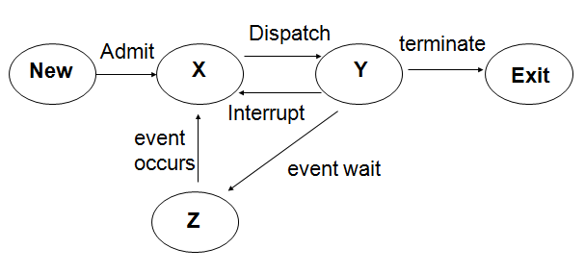
Figure 3
i) List state X, Y and Z. [1.5 marks]
Answer :
X :READY
Y :RUNNING
Z :WAITING

ii) Explain state X and Z. [3 marks]
Answer :
x: THE PROCESS IS WAITING TO BE ASSIGNED TO A CPU
Y:THE PROCESS IS WAITING FOR COME EVENT TO ACCRUE EX: I/OCOMPLATE

b) List THREE categories of contents in Process Control Block (PCB). [1.5 marks]

Answer:

c) Identify the correct commands in table below by selecting the answer options given. Assume you are in your working directory. [7 marks]
Answer Options:
A | cat testfork1.c
B | gcc testfork1.c
C | mkdir Result
D | gcc testfork1.c –o testfork1result
E | ls
F | view testfork1.c testfork2.c
G | cp testfork1.c testfork2.c
H | a.out
I | cd Result
J | dir Result

Tasks | Answer
Make another copy of testfork1.c file with name testfork2.c
Compile testfork1.c and specify the output filename as testfork1result
View the content of the file testfork1.c without using the editor.
Create a directory with name Result
List content of a directory
Change working directory to Result
What is default output filename generated after compiling the source code

QUESTION 4 [13 Marks]

a) The following table shows the trace addresses for 3 processes, A, B and C and the dispatcher in memory. These processes are running concurrently on a single processor system. Process A request an I/O resource at instruction cycle 4 and wait up to 30 instruction cycles. Then, process B request an I/O resource at instruction cycle 35 and wait up to 20 instruction cycles.

The processes and location.
Process | Addresses
A | 5000 – 5020
B | 7000 – 7050
C | 2000 – 2015
Dispatcher | 200 – 204

Complete Figure 4 by drawing the timeline of the process state for all processes within 70 instruction cycles with THREE different indicators for running, ready and blocked state. Assume the CPU time = 6 instruction cycles. [6 marks]

Answer:
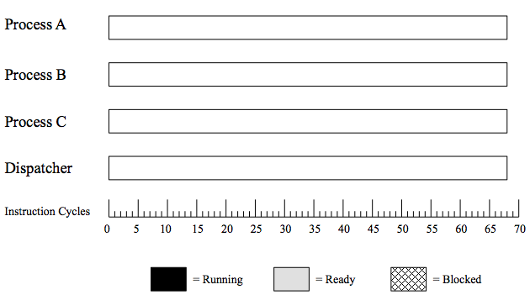

Figure 4
b) Consider program processTree.c in Figure 5. Draw the process tree for the execution of the program by drawing all processes created. Follow the example given in Figure 6 that must contain the value of new id of each new process and the expected output. Assume the initial process id = 3. [7 marks]

// processTree.c

int main() {

int pid1, pid2;

pid1 = fork();
print(“Operating system”);
pid2 = fork();
if (pid1 > pid2)
print(“is interesting”);
if (pid1 == pid2)
print(“I love OS”);
else
print(“Operating system”);

Figure 5: A part of C programming language.

pid1 =
pid2 =

Output:

id=

Figure 6: Example of each process.

Answer:

------------------------------------------------End of Question -------------------------------------------------

